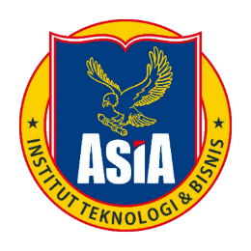

**Siti Murtini**

**Lorem Ipsum** is simply dummy text of the printing and typesetting industry. Lorem Ipsum has been the industry's standard dummy text ever since the 1500s, when an unknown printer took a galley of type and scrambled it to make a type specimen book. It has survived not only five centuries, but also the leap into electronic typesetting, remaining essentially unchanged

**19201040**

Diberikan Kepada

Mengetahui,

Keprodi Informatika

**Jaenal Arifin, S.Kom, M.M.,M.Kom**

**NIDN : 0709117502**

Ketua Himapro Sakti

**Mu’jizah Al Mu’allifah**

**NIM : 19201208**

**SERTIFIKAT**